**ROBOTICS**

**BY**

**MUSA ISA.A**

**ST/CS/ND/19/102**

**A SEMINAR PAPER PRESENTATION TO THE DEPARTMENT OF COMPUTER SCIENCE, SCHOOL OF SCIENCE AND TECHNOLOGY FEDERAL POLYTECHNIC MUBI, ADAMAWA STATE NIGERIA**

**IN PARTIAL FULFILLMENT OF THE REQUIREMENT FOR THE AWARD OF NATIONAL DIPLOMA (ND)**

**IN COMPUTER SCIENCE**

**NOVEMBER, 2021**

***ABSTRACT***

***This paper address the capability needed as a machine for the people to support in doing works at real-time sights as sound of a complex environment defined as machine in works. The constant development of robotic equipment is paving way for the provision of an easy work machine and how to perform action as a human being.***

**INTRODUCTION**

**Ivy Wigmore (January, 2009) Describe robot as a type of automated machine that can execute specific tasks with little or no human intervention and with speed and precision. The field of robotics, which deals with robot design, engineering and operation, has advanced remarkably in the last 50 years.   
 IDC identifies robotics as one of six innovation accelerators driving digital transformation. The others include 3D printing, cognitive computing, next-generation security and virtual reality or augmented reality. Essentially, there are as many different types of robots as there are tasks for them to perform. Robots can perform some tasks better than humans, but others are best left to people and not machines. The following are things robots do better than humans: Automate manual or repetitive activities in corporate or industrial settings. Work in unpredictable or hazardous environments to spot hazards like gas leaks. Process and deliver reports for enterprise security. Fill out pharmaceutical prescriptions and prep IVs. Deliver online orders, room service and even food packets during emergencies. Assist during surgeries. Robots can also make music, monitor shorelines for dangerous predators, help with search and rescue and even assist with food preparation. Connected to the cloud IDC predicted in its 2019 Future Scape report on robotics that of 40% of G2000 manufacturers will digitally connect (at least) around a third of their robots to cloud platforms to improve agility and operational efficiency by 2023. Furthermore, 25% of retailers will deploy robots to free workers from performing repetitive tasks. Despite their increasing ubiquity, there are several\ shortcomings to using robots. They can, for example: perform surgeries but not soothe scared patients; sense furtive footsteps in a closed-off area, but not take action against gate-crashers; lead exercise sessions for the elderly but not ease their loneliness; help medical professionals with diagnoses, but not empathize with patients; and learn from data, but not correctly respond to unexpected situations. The increasingly complex capabilities of robots will eventually eliminate some human tasks, but not all. Current robotics technology can automate only 25% of tasks in unpredictable, human-dependent areas like construction and nursing. But robots depend on human programming -- and they (likely) always will.**

**Types of robot**

**Charlie Chaplin, (December. 1940), There are as many different types of robots as there are tasks:**

1. **Androids Robot: Androids are robots that resemble humans. They are often mobile, moving around on wheels or a track drive. According to the American Society of Mechanical Engineers, these humanoid robots are used in areas such as caregiving and personal assistance, search and rescue, space exploration and research, entertainment and education, public relations and healthcare, and manufacturing. As use cases and applications explode, the android market is poised to hit $13 billion by 2026.**
2. **Telechir Robot: A telechir is a complex robot that is remotely controlled by a human operator for a telepresence system. It gives that individual the sense of being on location in a remote, dangerous or alien environment, and enables them to interact with it since the telechir continuously provides sensory feedback.**
3. **Telepresence robot: A telepresence robot simulates the experience – and some capabilities -- of being physically present at a location. It combines remote monitoring and control via telemetry sent over radio, wires or optical fibers, and enables remote business consultations, healthcare, home monitoring, childcare and more.**
4. **Industrial robot: The IFR (International Federation of Robotics) defines an industrial robot as an "automatically controlled, reprogrammable multipurpose manipulator programmable in three or more axes." Users can adapt these robots to different applications as well. Combining these robots with AI has helped businesses move them beyond simple automation to higher-level and more complex tasks. In 2019, there were over 390,000 industrial robots installed worldwide, according to the IFR -- with China, Japan and the U.S. leading the way. In industrial settings, such robots can do the following: optimize process performance; automate production to increase productivity and efficiency; speed up product development; enhance safety; and lower costs.**
5. **Swarm robot: Swarm robots (aka insect robots) work in fleets ranging from a few to thousands, all under the supervision of a single controller. These robots are analogous to insect colonies, in that they exhibit simple behaviors individually, but demonstrate behaviors that are more sophisticated with an ability to carry out complex tasks in total.**
6. **Smart robot: this is the most advanced kind of robot. The smart robot has a built-in AI system that learns from its environment and experiences to build knowledge and enhance capabilities to continuously improve. A smart robot can collaborate with humans and help solve problems in areas like the following: agricultural labor shortages; food waste; study of marine ecosystems; product organization in warehouses; and clearing of debris from disaster zones. Not all robots look like HAL 9000 in 2001: A Space Odyssey or BigDog -- a rough-terrain quadruped robot with complex sensors, gyroscopes and hydraulic actuators -- from Boston Dynamics. Some have human-like features (androids), while others are all mechanical limbs (PackBot).**

**Tolls for making robot**

1. Small vise: you'll need this.
2. Hammer: A hammer is one of the standard tools you'll need.
3. Screwdrivers & Wrenches: their uses are obvious. Two spanners of equal size are required for lock-nutting.
4. Saw: Metal and wood saws. Miter saws can be very handy, but are pretty expensive. A miter box might suffice for many purposes.
5. Square, measuring tape, scriber and other marking out tools.
6. Venire calipers: Allow very accurate marking out and measurement. Also can be used to check thread pitch on machine screws without a dedicated pitch gauge.
7. Files: especially when working with metal, as rough metal edges are sharp.
8. Center Punch: Essential for accurate drilling of holes in metal to prevent the drill skating over the surface.
9. Drill Press: (small table top versions suffice) is very handy for drilling accurate holes. Can also provide the low speeds for drilling large holes in metal, which hand drills cannot do easily.
10. Hobby Tool: Useful for many purposes.
11. Sharp utility knives: Mostly used when working with plastics.
12. Hot glue guns: handy for quickly mounting parts. Not too strong bound, but useful for many applications.
13. Arc Welder: Only useful when working with thick steel on large projects (use a gas welding torch for thin metal;arc welders tend to burn holes right through the work-piece). Aluminium cannot be welded with ordinary welders. (Unless you have a MIG/MAG or TIG welder available)
14. Paint stripper/Electric Heat Gun: like a hairdryer on steroids. Useful for bending plastics, also applying heat-shrink tubing to electric cables at low power.
15. Safety Goggles: You only get one pair of eyes, and machine tools are potentially dangerous. Safety goggles are essential for using anything other than hand tools.

**Architectural structure of robotic**

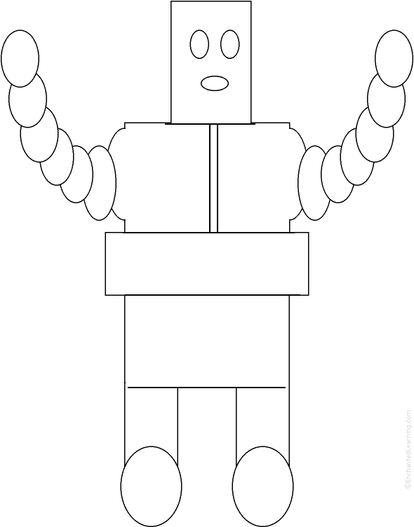

**Figure 1**

**Advantages of Robot**

**According to Vaughan, Sumpter (March 2017). Learn more in these related Britannica articles: A robot may not injure a human being or, through inaction, allow a human being to come to harm.**

1. **A robot must obey the orders given it by human beings except where such orders would conflict with the First Law.**
2. **A robot must protect its own existence as long as such protection does not conflict with the First and Second Laws.**
3. **Isaac Asimov robot stories (later collected in I, Robot [1950]). In the 21st century, “positronic” robots...… short story short story, brief fictional prose narrative that is shorter than a novel and that usually...… science fictionscience fiction, a form of fictionthat deals principally with the impact.**

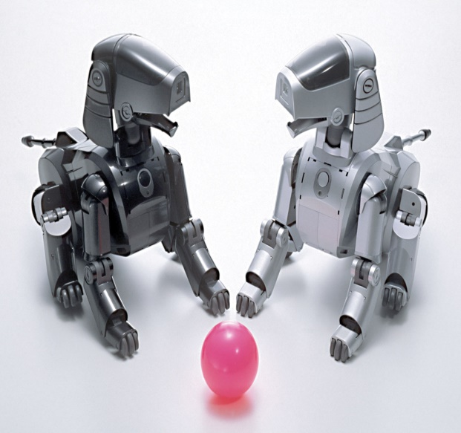

**Figure 2**

**Disadvantage of Robot**

**Vaughan, Sumpter (March 2017). Agure that the use of robots can create economic problems if they replace human jobs Robots can only do what they are told to do – they can’t improvise This means that safety procedures are needed to protect humans and other robots Although robots can be superior to humans in some ways, they are less dexterous than humans, they don’t have such powerful brains, and cannot compete with a human’s ability to understand what they can see. Often robots are very costly – in terms of the initial cost, maintenance, the need for extra components and the need to be programmed to do the task.**

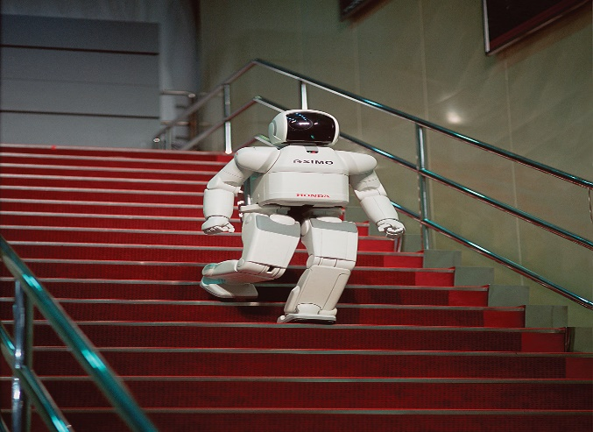

**Figure 3**

**Literature Review**

**The first industrial robot was introduced to the U.S. in the 1960s. Since then, their technology has improved immensely creating many advantages of robots. The advancement of robotics has also caused robots to become more widespread across various industries ranging from manufacturing to health care. Many benefits of robots seem to be most noticeable in productivity, safety, and in saving time and money. Productivity Robots produce more accurate and high quality work. Robots rarely make mistakes and are more precise than human workers. They can produce a greater quantity in a short amount of time. They can work at a constant speed with no breaks, days off, or holiday time. They can perform applications with more repeatability than humans. Safety Robots save workers from performing dangerous tasks. They can work in hazardous conditions, such as poor lighting, toxic chemicals, or tight spaces. They are capable of lifting heavy loads without injury or tiring. Robots increase worker safety by preventing accidents since humans are not performing risky jobs. Work cells provide safety features, separating the worker from harm’s way.**

**Vaughan, Sumpter (March 2017). Savings Robots save time by being able to produce a greater magnitude of products They also reduce the amount of wasted material used due to their accuracy Robots save companies money in the long run with quick ROIs (return on investment) , fewer worker injuries (reducing or eliminating worker’s comp), and with using less materials. The list of the advantages of robots does not end there; they have also created jobs for workers. Many people believe the misconception that robots have taken away jobs from workers, but that is not necessarily true. Robots have created new jobs for those who were once on production lines with programming. Contact RobotWorx at 740-251-4312 for help in choosing the right robot or get free price quotes. Common characteristics of robots Robotic process automation and intelligent process automation Robots and robotics: A short history Continue Reading About robot How Amazon launched the warehouse robotics industry ∙ Robotics company Berkshire Grey will go public ∙ IoT robotics prevents hazards in manufacturing and healthcare ∙ How AI can be used in agriculture: Applications and benefits ∙ Understanding the difference between RPA and AI ∙ Dig Deeper on AI business strategies robot economy By:(Ivy Wigmore) AI in space exploration leads to more independent robots By:(Paul Kostek) How the relationship between humans and computers has evolved By: Steve Wilson How the three phases of automation dictate human employment By(Bob Reselman).**

**Conclusion**

**Vincent, Antony (January, 2019) Mechanical construction electrical components computer programming As AI and software advance, robots will become smarter, more efficient and will take on more complex challenges. Robotic process automation (RPA) technology involves the design, deployment and use of software-based robots to accomplish things like the following: automate rules-based business processes; streamline enterprise operations; save human effort; and lower costs. RPA automates repetitive tasks so human personnel can focus on more higher-value work. Use cases can be simple (automated email responses) or complex (automating thousands of jobs). Sir Charlie Chaplin, The Great Dictator In 1940, Sir Charlie Chaplin probably had no idea that the inexorable rise of machines was just a few decades away. Over 80 years later, automated robots are now used in manufacturing, industrial supply chains, agriculture, financial services, education and more. By the 1990s, consumer-facing bots appeared as computer games like Tamagotchi.**

**Reference**

**Charlie Chaplin, The Great Dictator In (December. 1940), *probably inexorable rise  
 of machines was just a few decades away USA.***

**(Ivy Wigmore January, 2009) Describe robot as an automated machine*. USA*** [*http://www1.electusdistribution.com.au/images_uploaded/*](http://www1.electusdistribution.com.au/images_uploaded/) *IDCconnE.*

**Vaughan, R. N. Sumpter (March 2017). A. Frost, and S. Cameron. "Experiments  
 in *http://www1.electusdistribution.com***

**Vincent, Antony (January, 2019) Automatic Flock Control." Edinburgh, UK, 1998.   
 *http://www1.electusdistribution.com***